DBC2 150W THERMAL TESTS
SAMPLE UNIT 4

18.05.2023
ENKO
All thermal tests held down with the sample product according with this specs:
- 150W Sample
- 15VDC 10A Configuration.
- 230VAC line voltage.
- With the closed environment.
- All tests were started in a room temperature.

Test specifics:

Test 1:
- Unit mounted on a rack upside down. (AC line was on downside and DC side was on upside.)
- Black box of the unit itself was closed.
- Measurements were made from outside of the box with a thermal camera.

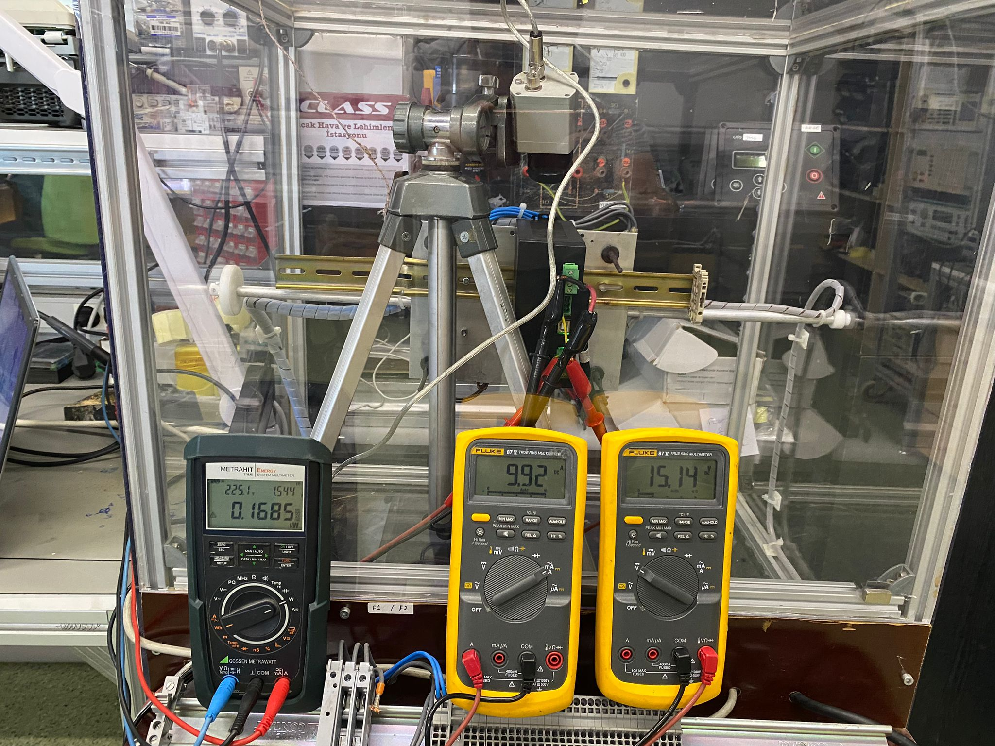
Image 1 – Wrong mounted test setup. (From right: AC Power meter, IDC, VDC)

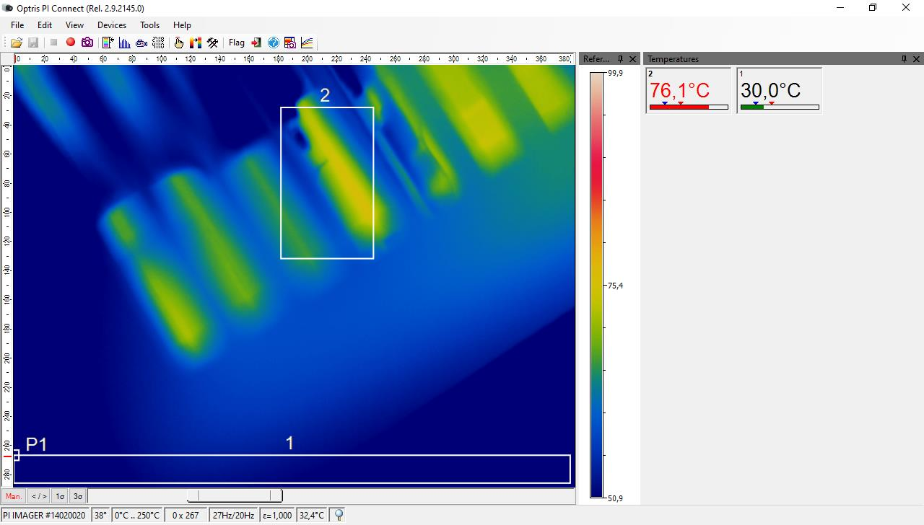
Image 2 – Wrong mounted, Seconder MOSFET.

Image 3 – Wrong mounted, Primer MOSFET.

Test 2:
- Unit mounted on a rack right side up. (AC line was on upside and DC side was on downside.)
- Black box of the unit itself was closed.
- Measurements were made from outside of the box with a thermal camera.

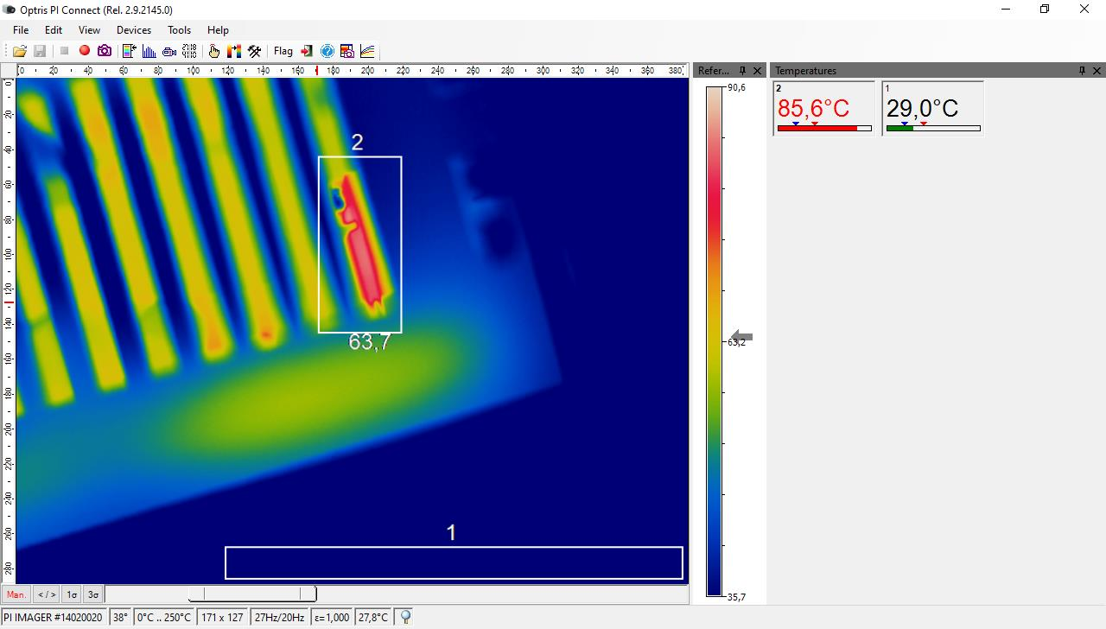
Image 4 – Normal mounted Primer MOSFET.

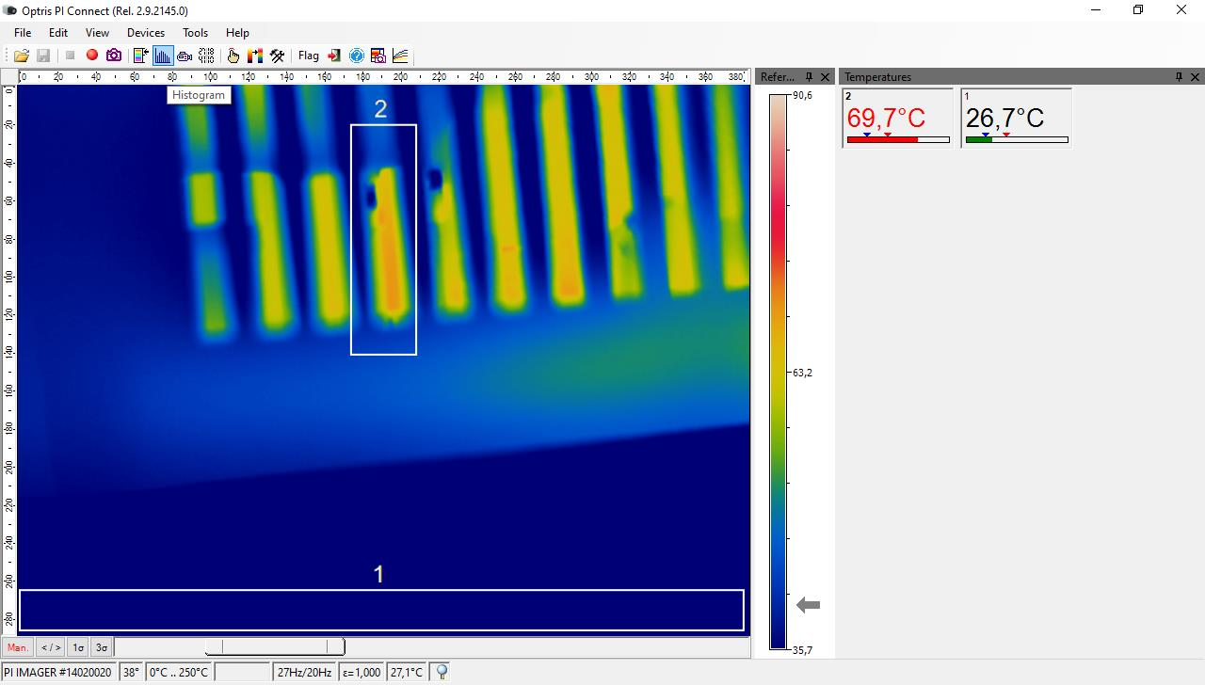
Image 5 – Normal mounted Seconder MOSFET.

Test 3:
- Unit mounted on a rack upside down. (AC line was on downside and DC side was on upside.)
- Box of the unit was open.
- Measurements were made from outside of the box with a thermal camera.

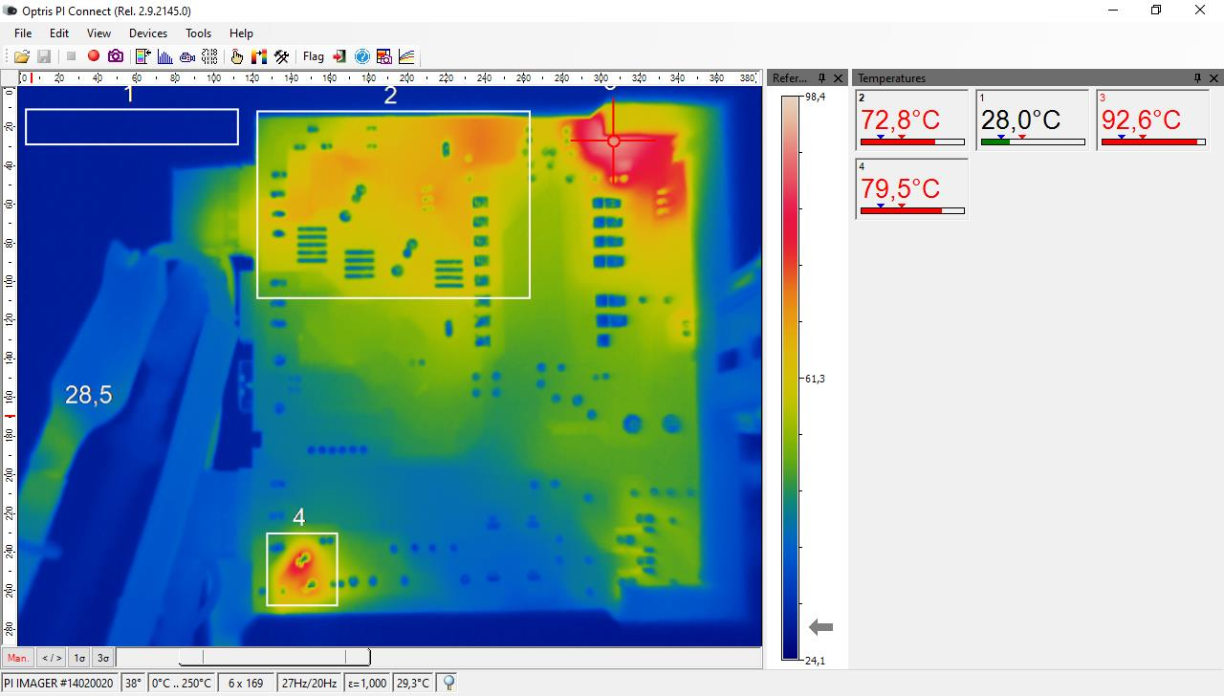
Image 6 – Wrong mounted Backside of PCB. (4: NTC PCB, 2: Seconder PCB, 3 Pri Snubber PCB)

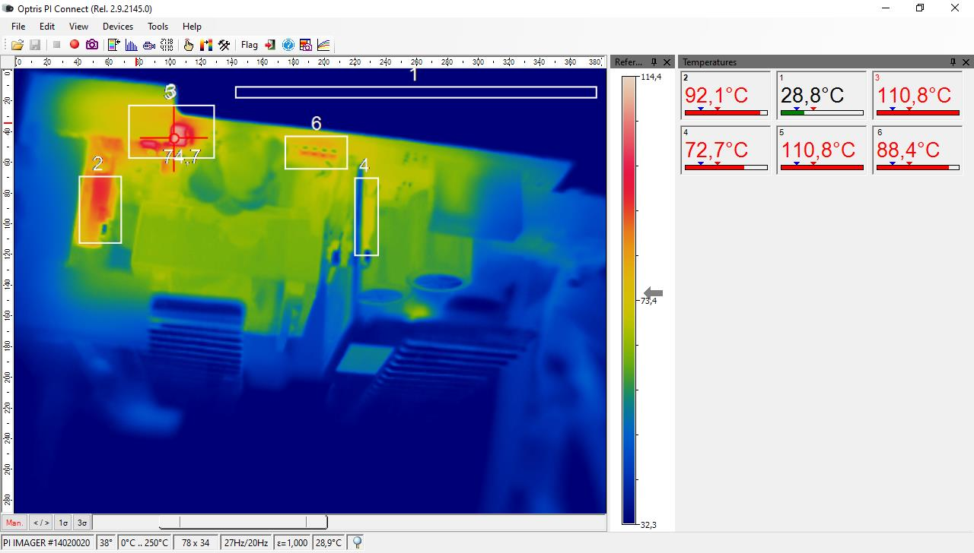
Image 7 – Wrong mounted, MOSFETs. (From right: Pri MOS, Pri Snubbers, Sec Snubbers, Sec MOS)

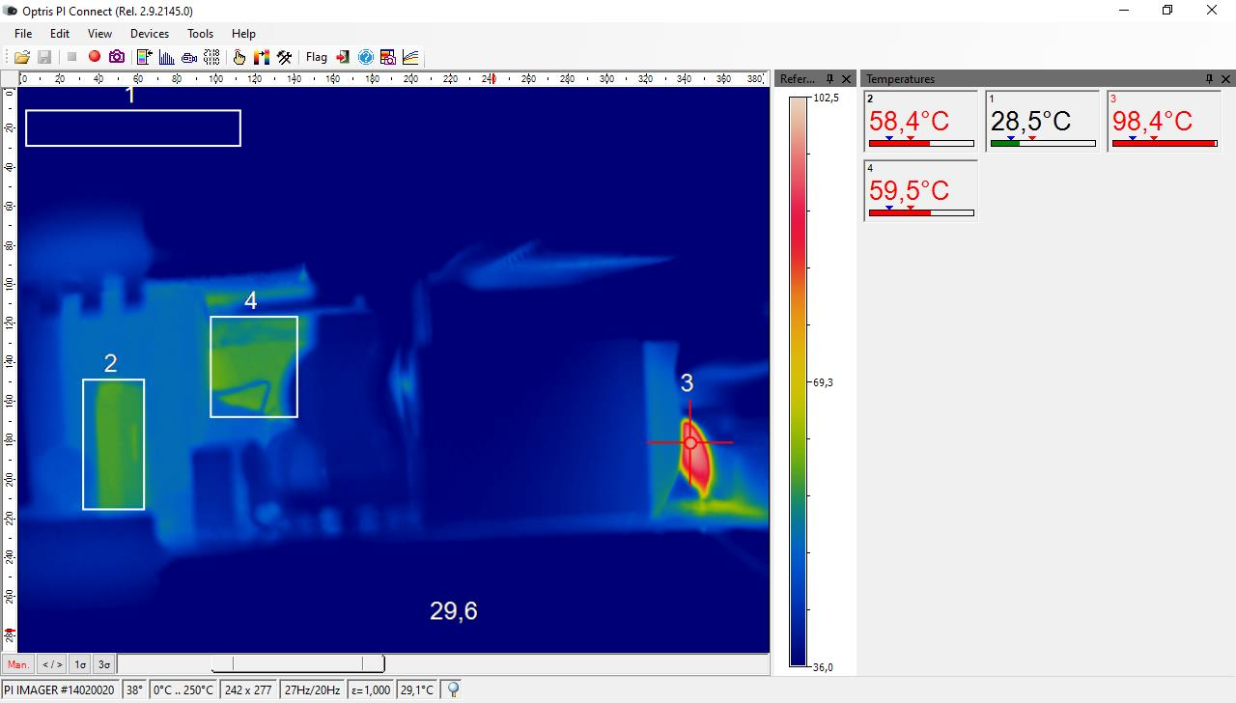
Image 8 – Wrong mounted, NTC. (From right Bridge, Pri MOS, NTC)

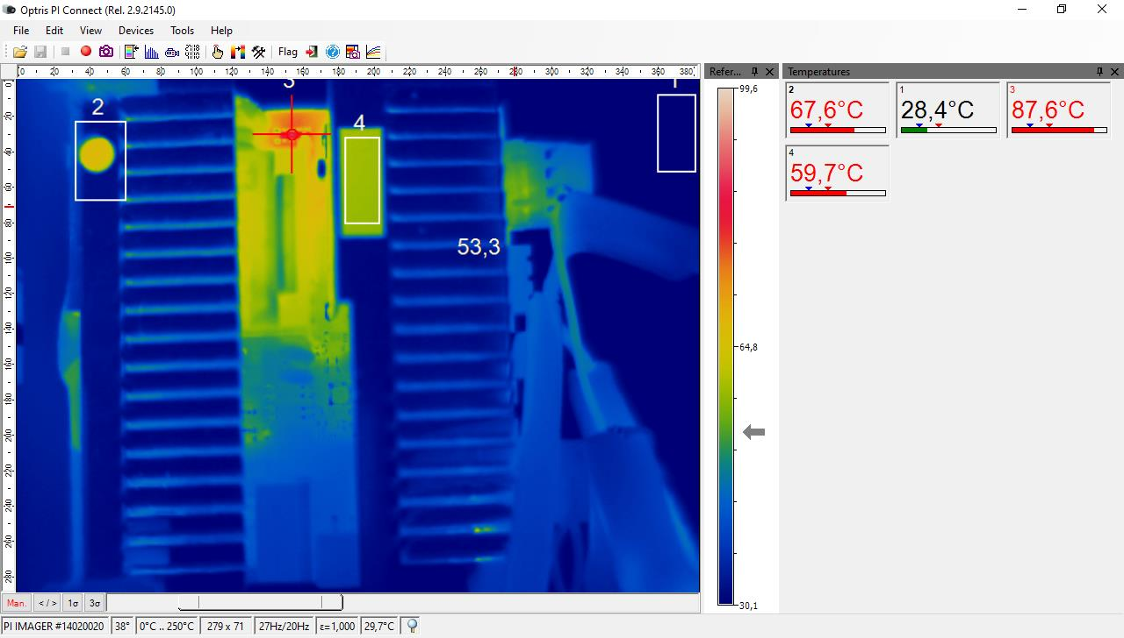
Image 9 – Wrong mounted, Snubbers. (From right: 2: Pri heatsink, 3: Pri snubbers, 4: Seconder heatsink)

Test 4:
- Unit mounted on a rack right. (AC line was on upside and DC side was on downside.)
- Black box of the unit itself was closed.
- Measurements were made from outside of the box with a thermal camera.

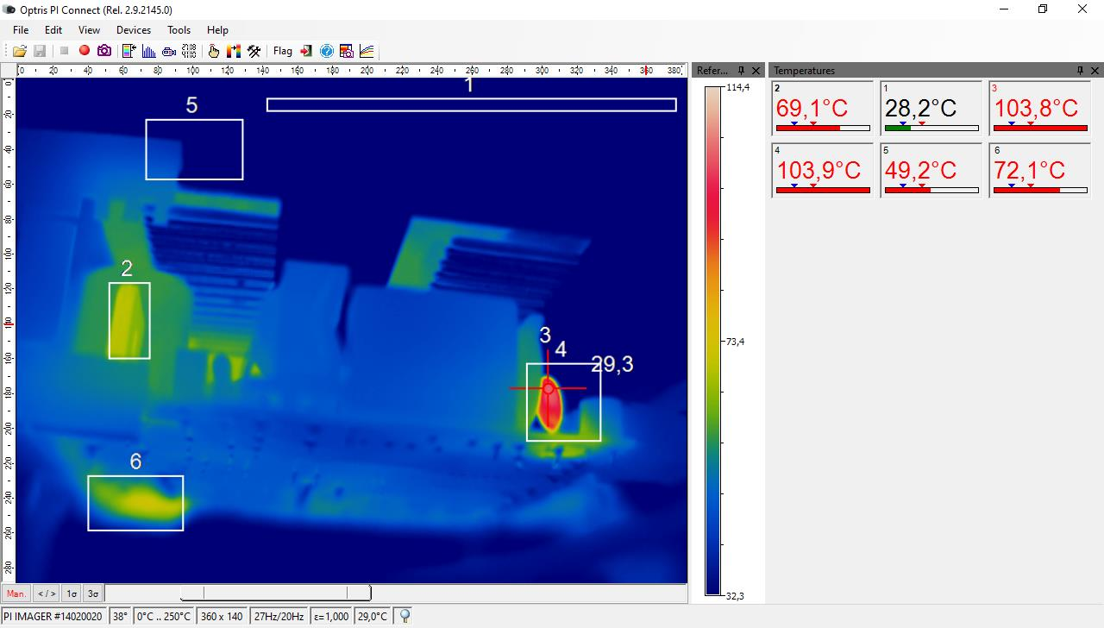
Image 10 – Normal mounted, Bridge and NTC. (From right: 6:Pri snubber PCB, 2: Bridge, 3 and 4: NTC)

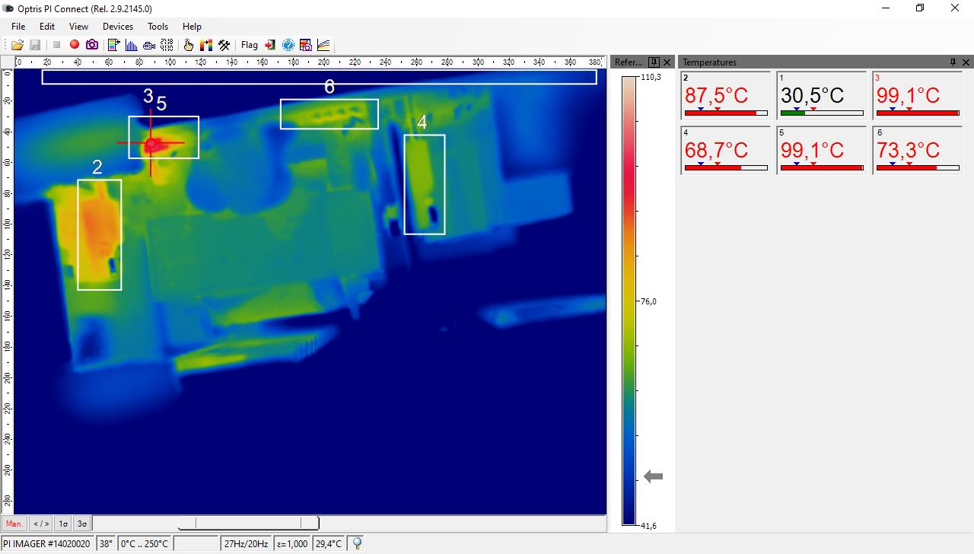
Image 11 – Normal mounted, MOSFETs and Snubbers. (From right: Pri MOS, Pri Snubbers, Sec snubbers, Sec MOS.)

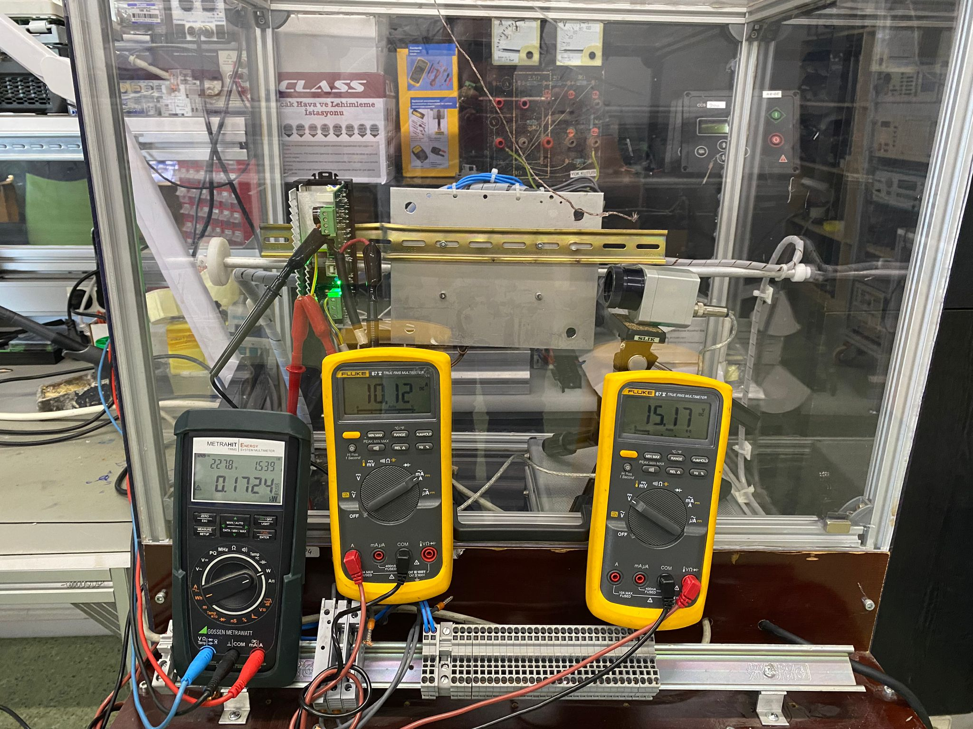
Image 12 – Wrong mounted open test setup. (From right: AC Power meter, IDC, VDC)

Test Number | Pri MOSFET(°C) | Sec MOSFET(°C) | Bridge Rect.(°C) | Pri Snubber(°C) | NTC PCB(°C) | Pri Snubber PCB(°C) | Environment (°C)
Test 1 | 88,9 | 76,1 | - | - | - | - | 27
Test 2 | 85,6 | 69,7 | - | - | - | - | 28
Test 3 | 92,1 | 72,7 | 58,4 | 110,8 | 98,4 | - | 28
Test 4 | 87,5 | 68,7 | 69,1 | 99,1 | 103,8 | 72,1 | 29

